24CSI024L-DATA STRUCTURES AND ALGORITHMS
Exp nO : 1
Name : SRIDHAR T
Roll No : 25BAD112
Date : 23.07.2026

Implementation of an Array ADT Using Linear Search and Binary Search
Aim:
To implement an Array ADT in C and perform Linear Search and Binary Search operations on the array.
Pseudo Code:
START

Read n
Read array elements

Display array

Read key

// Linear Search
FOR i = 0 TO n - 1
IF array[i] == key THEN
Print "Element found at index", i
BREAK
END IF
END FOR

IF element not found THEN
Print "Element not found"
END IF

// Binary Search (Array must be sorted)
low = 0
high = n - 1

WHILE low <= high
mid = (low + high) / 2

IF array[mid] == key THEN
Print "Element found at index", mid
BREAK
ELSE IF key < array[mid] THEN
high = mid - 1
ELSE
low = mid + 1
END IF
END WHILE
IF element not found THEN
Print "Element not found"
END IF
STOP
CODE:
#include <stdio.h>
struct Array {
int a[100], n;
};

void display(struct Array arr) {
for(int i = 0; i < arr.n; i++)
printf("%d ", arr.a[i]);
}

int linearSearch(struct Array arr, int key) {
for(int i = 0; i < arr.n; i++)
if(arr.a[i] == key)
return i;
return -1;
}

int binarySearch(struct Array arr, int key) {
int low = 0, high = arr.n - 1, mid;
while(low <= high) {
mid = (low + high) / 2;
if(arr.a[mid] == key) return mid;
if(key < arr.a[mid])
high = mid - 1;
else
low = mid + 1;
}
return -1;
}

int main() {
struct Array arr;
int key;

printf("Enter size: ");
scanf("%d", &arr.n);

printf("Enter sorted elements: ");
for(int i = 0; i < arr.n; i++)
scanf("%d", &arr.a[i]);

display(arr);

printf("\nEnter element to search: ");
scanf("%d", &key);

printf("Linear Search Index: %d\n", linearSearch(arr, key));
printf("Binary Search Index: %d\n", binarySearch(arr, key));

return 0;
}
Sample Input and Output:

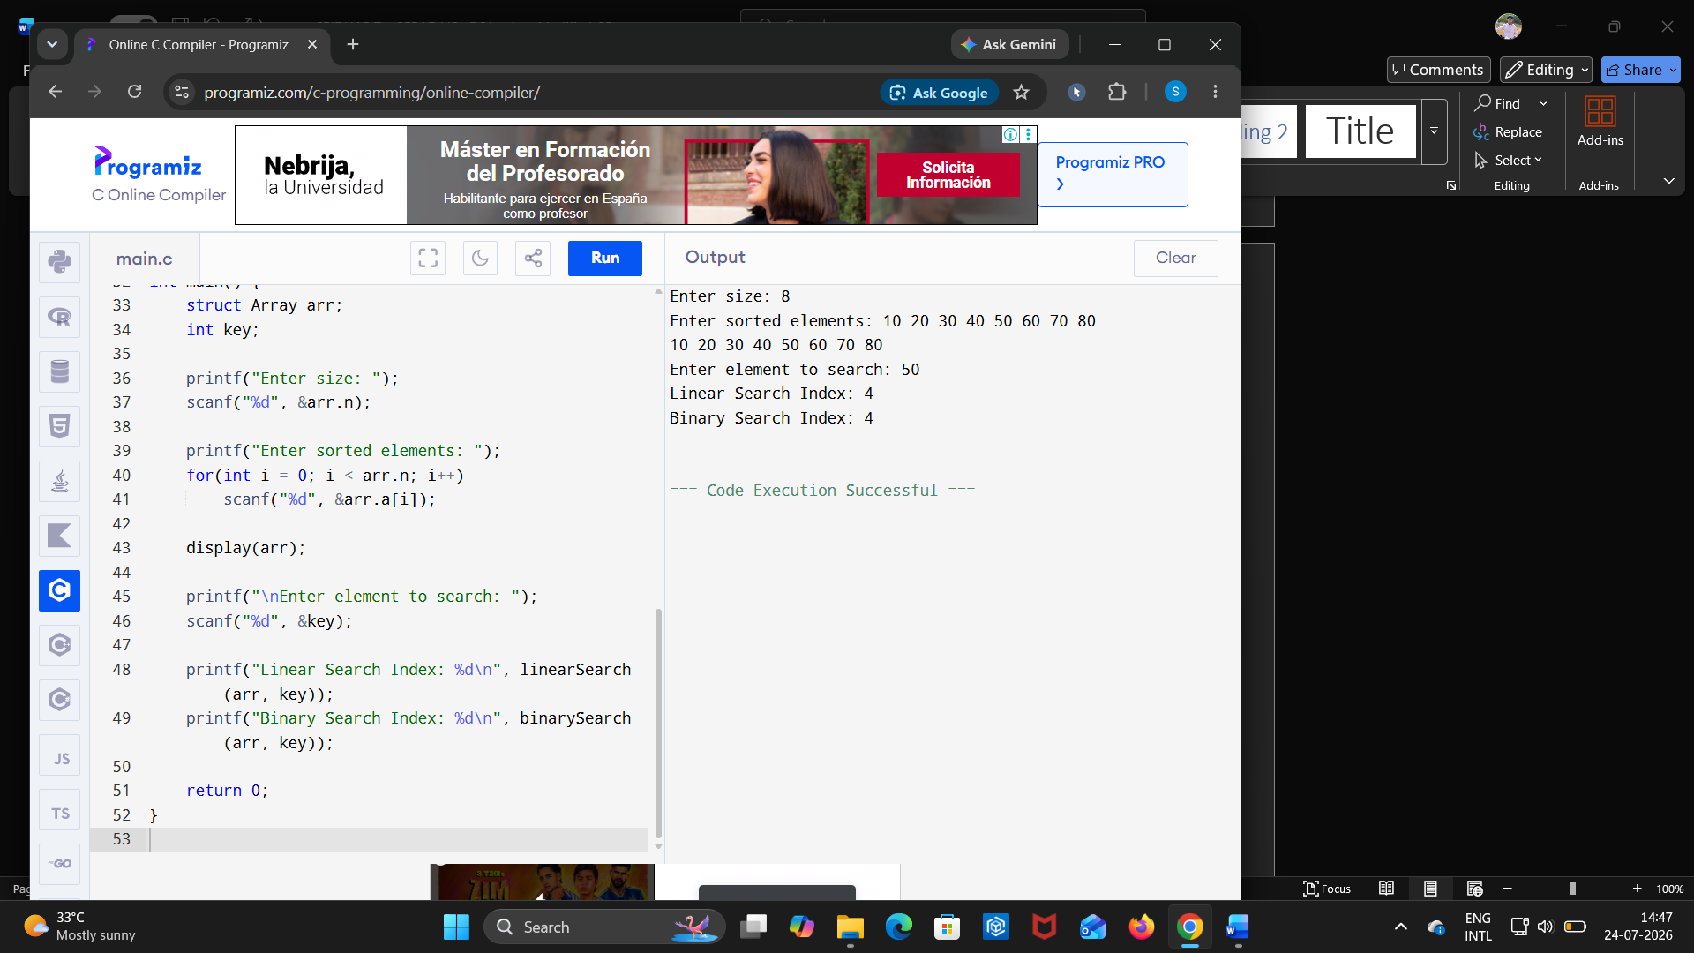
LINK :
https://github.com/24CSI024-25BAD112/24CSI024-25BAD112/blob/main/Untitled1.c

Result:
Result: The Array Abstract Data Type (ADT) was successfully implemented in C, and the Linear Search and Binary Search operations were performed successfully. The required element was searched and its index was displayed correctly.

